NPC – UNIT 3 ASSIGNMENT
REPORT
Topic: Configure a DNS Server and Web Server Using Cisco Packet Tracer

Submitted by: Siddhi Rajesh Lute
PRN Number: 2125UCSF1098
Semester: 3
Subject: NPC
Department: Cyber Security
College: Sanjivani University
Academic Year: 2026-27

1. Aim :
To design and configure a computer network using Cisco Packet Tracer, set up a Domain Name System (DNS) server and a web server, and verify successful communication between client computers and the servers.

2. Objectives :
- To create a network topology using PCs, a switch, a DNS server, and a web server.
- To assign IP addresses to all devices.
- To configure the DNS service and add a domain name record.
- To enable the HTTP service on the web server.
- To test network connectivity using the ping command.
- To access the website using its domain name through a web browser.

3. Software and Requirements :
Software required: Cisco Packet Tracer
Network devices used:
- 2 client computers: PC0 and PC1
- 1 Cisco 2960 switch
- 1 DNS server: Server0
- 1 web server: Server1
- Copper straight-through Ethernet cables

4. Introduction :
A computer network allows devices to communicate and share information with one another. In this practical, a small local area network (LAN) is created using Cisco Packet Tracer.
A DNS server translates a domain name into its corresponding IP address. A web server stores and delivers website content to clients using the HTTP protocol.
In this network, Server0 is configured as the DNS server, and Server1 is configured as the web server. The domain name www.mywebsite.com is mapped to the web server's IP address, 192.168.1.3. The client computers use this domain name to access the website.

5. Network Topology :
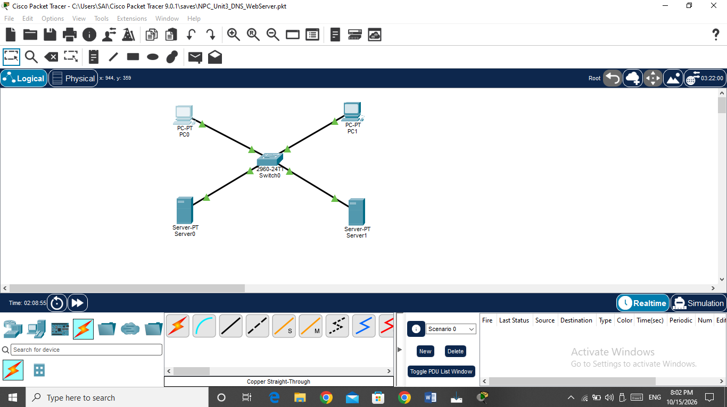
The network consists of two PCs, one switch, one DNS server, and one web server. All devices are connected to the switch using copper straight-through cables.
Figure 1: Network topology designed in Cisco Packet Tracer.
Connections Used :
Device | Connected to switch port
PC0 | FastEthernet0/1
PC1 | FastEthernet0/2
Server0 (DNS) | FastEthernet0/3
Server1 (Web) | FastEthernet0/4
The switch acts as a central device that enables communication between all connected devices.

6. IP Address Configuration :
Each device was assigned a unique IP address within the same network, 192.168.1.0/24. The subnet mask used for all devices is 255.255.255.0.

IP Address Table :

Device | IP address | Subnet mask | DNS server
PC0 | 192.168.1.10 | 255.255.255.0 | 192.168.1.2
PC1 | 192.168.1.11 | 255.255.255.0 | 192.168.1.2
Server0 (DNS) | 192.168.1.2 | 255.255.255.0 | 192.168.1.2
Server1 (Web) | 192.168.1.3 | 255.255.255.0 | 192.168.1.2
Default gateway: Not configured; it is not required for communication within this local network.

Procedure :
- Opened Cisco Packet Tracer and created the network topology.
- Connected all devices to the switch using copper straight-through cables.
- Opened each PC and server.
- Selected the Desktop → IP Configuration option on each device.
- Entered the assigned IP address and subnet mask.
- Set the DNS server address to 192.168.1.2 on the client computers.

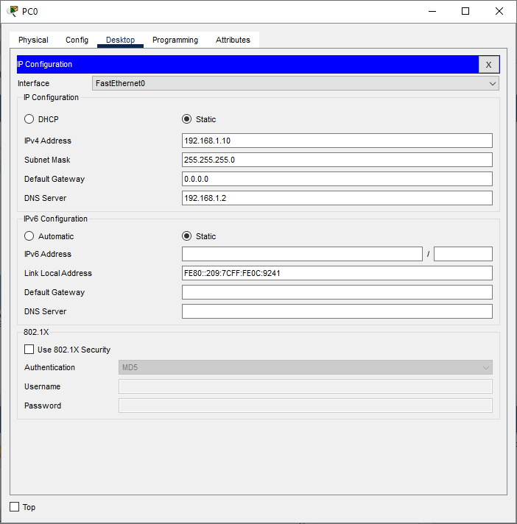
Figure 2: IP address and DNS settings of PC0.

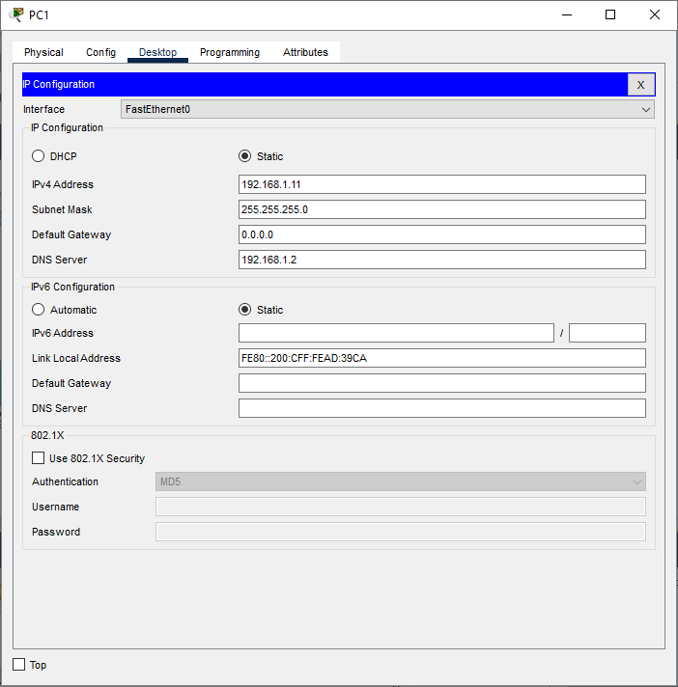
Figure 3: IP address and DNS settings of PC1.

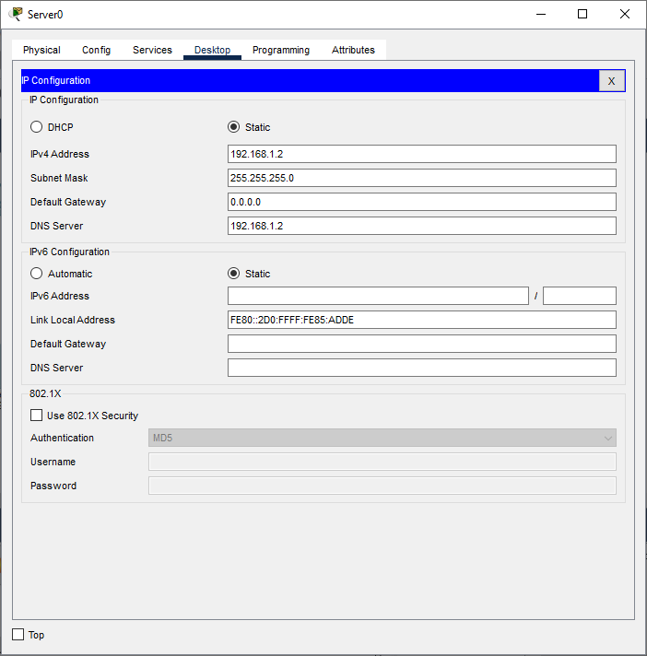
Figure 4: IP address configuration of the DNS server.
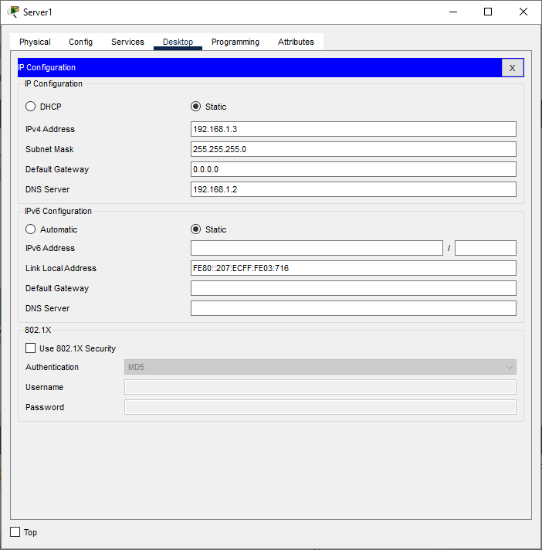
Figure 5: IP address configuration of the web server.

7. DNS Server Configuration :
DNS stands for Domain Name System. It converts human-readable domain names into IP addresses so that users can access websites without remembering their numerical addresses.
In this practical, Server0 is configured as the DNS server.

Procedure :
- Clicked Server0.
- Opened the Services tab.
- Selected DNS from the left-side menu.
- Turned the DNS service On.
- Added a DNS A record with the following details:
Field | Value
Name | www.mywebsite.com
Type | A Record
Address | 192.168.1.3
- Added the record to the DNS table.
The A record maps the domain name www.mywebsite.com to the IP address of Server1, the web server.

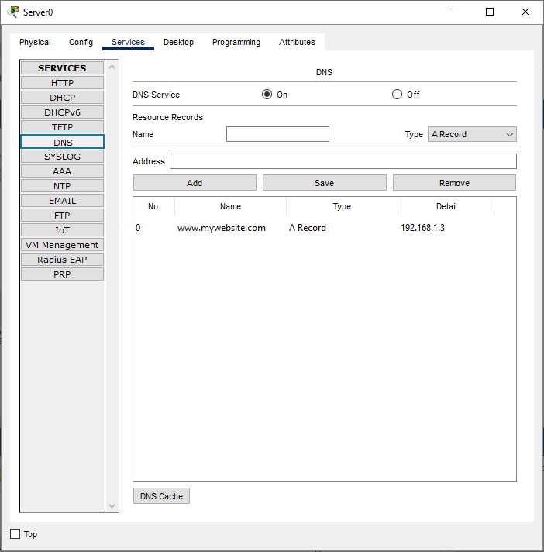
Figure 6: DNS service enabled with the website's A record.

8. Web Server Configuration :
A web server stores website files and provides them to client computers through a web browser. HTTP (Hypertext Transfer Protocol) is used to deliver web pages.
In this practical, Server1 is configured as the web server.

Procedure :
- Clicked Server1.
- Opened the Services tab.
- Selected HTTP.
- Turned the HTTP service On.
- Kept the default web page available for testing.
The web server uses the IP address 192.168.1.3. The DNS server points the domain name www.mywebsite.com to this address.
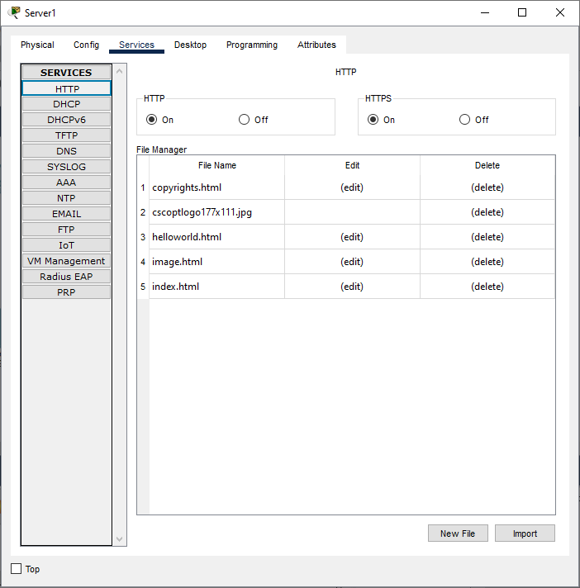

Figure 7: HTTP service enabled on the web server.

9. Testing and Verification :
After configuring the devices and services, connectivity and website access were tested from PC0.

9.1 Testing Connectivity to the DNS Server
The following command was entered in the PC0 Command Prompt:
ping 192.168.1.2
Result: Replies were received from the DNS server, indicating successful network connectivity.

9.2 Testing Connectivity to the Web Server
The following command was entered:
ping 192.168.1.3
Result: Replies were received from the web server, indicating successful network connectivity.

9.3 Testing DNS Name Resolution
The following command was entered:
ping www.mywebsite.com
Result: Replies were received after the domain name was resolved to the web server's IP address, 192.168.1.3. This confirmed that DNS name resolution was working.

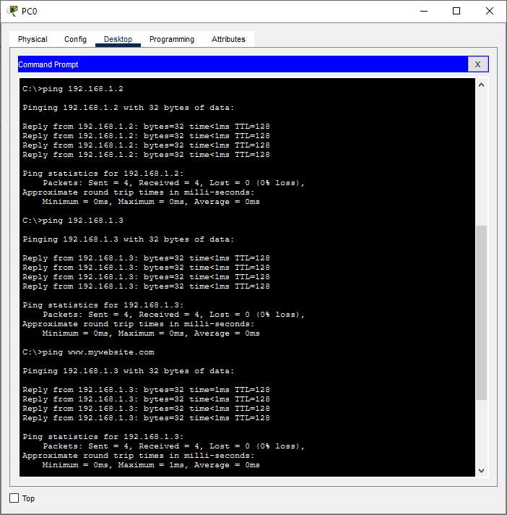
Figure 8: Successful connectivity and DNS resolution tests from PC0.

9.4 Accessing the Website :
- Opened PC0.
- Selected Desktop → Web Browser.
- Entered the following URL in the address bar:
http://www.mywebsite.com
- Clicked Go to open the website.
Result: The web page opened successfully in the browser. This verified that the DNS server resolved the domain name correctly and that the web server responded to the HTTP request.
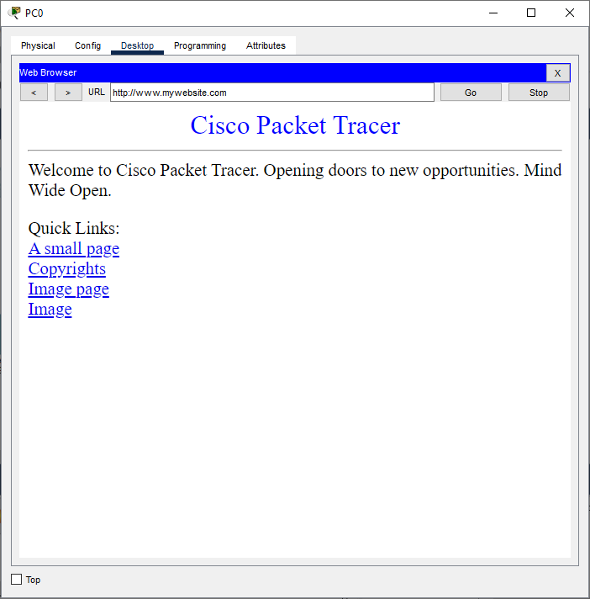
Figure 9: Successful access to the website using its domain name.

10. Results :
The practical was completed successfully. The following results were observed:
- The network topology was created successfully in Cisco Packet Tracer.
- All devices were assigned their respective IP addresses.
- The DNS service was enabled on Server0.
- The DNS A record was created for www.mywebsite.com.
- The HTTP service was enabled on Server1.
- The ping tests to the DNS server and web server were successful.
- The domain name resolved to 192.168.1.3.
- The website was accessed successfully through the web browser.

11. Conclusion :
In this practical, a DNS server and a web server were configured successfully using Cisco Packet Tracer. The client computers were assigned IP addresses and configured to use the DNS server. An A record was added to map www.mywebsite.com to the web server's IP address, and the HTTP service was enabled.
The successful ping tests and browser access confirmed that the devices could communicate, DNS name resolution worked, and the web server delivered its web page. Thus, the objectives of the practical were achieved.

12. Learning Outcome :
Through this practical, I learned how to:
- Design a basic LAN topology in Cisco Packet Tracer.
- Configure IP addresses and subnet masks.
- Enable and configure DNS and HTTP services.
- Create a DNS A record to map a domain name to an IP address.
- Test connectivity using the ping command.
- Access a website using its domain name.

